H.T No
Regulations:
A18

Sreenidhi Institute of Science and Technology
(An Autonomous Institution)
Code No: 7BC02 Date: 10-July-2021 (FN)

B.Tech I-Year I- Semester External Examination, July-2021 (Supplementary)
ENGINEERING GRAPHICS AND DESIGN (EEE, ME and ECE)

Time: 3 Hours Max.Marks:70

Note: a) No additional answer sheets will be provided.
b) All sub-parts of a question must be answered at one place only, otherwise it will not be valued.
c) Missing data can be assumed suitably.

ANSWER ANY 5 OUT OF 8 QUESTIONS. EACH QUESTION CARRIES 14 MARKS.

Bloom's Cognitive Levels of Learning (BCLL)

Remember | L1 | Apply | L3 | Evaluate | L5
Understand | L2 | Analyze | L4 | Create | L6

 |  |  | BCLL | CO(s) | Marks
1. |  | Construct a hyperbola, with a distance between the focus and the directrix as 65mm and eccentricity is 3/2 and draw normal and tangent to the curve at a point 35mm from the directrix | L4 | CO1 | [14M]
2. |  | A line AB is 60mm long and inclined at 30° to H.P and 45º to V.P. The end A of the line is 20mm above H.P and 25mm in front of V.P. Draw the projection of the line. | L3 | CO2 | [14M]
3. |  | A regular hexagonal plane of 30mm side, has a corner at 25mm from V.P and 50mm from H.P .Its surface is inclined at 45° to V.P and perpendicular to H.P. Draw the projections of the plane. | L3 | CO3 | [14M]
4. |  | A cylinder of diameter of base 40mm and axis 60mm long, is resting on its base on H.P. It is cut by a section plane perpendicular to V.P. and inclined at 45º to H.P. the section plane is passing through the top end an extreme generator of the cylinder. Draw the development of the lateral surface of the cut cylinder. | L4 | CO4 | [14M]
5. |  | Draw the Isometric projection of a cylinder when its axis is i) vertical ii) Horizontal. The diameter of the cylinder is 30mm and its axis is 60mm long. | L3 | CO5 | [14M]
6. | a) | Define CAD? Explain its advantages. | L3 | CO6 | [7M]
 | b) | List out editing commands, drawing commands. | L2 | CO6 | [7M]
7. |  | Construct the rectangular hyperbola passing through the point P with coordinates20mm and 30mm. | L3 | CO1 | [14M]
8. |  | Draw the orthographic view of below figure.  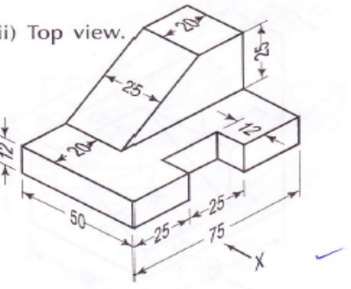 | L5 | CO4 | [14M]
-- 00 -- 00 –

